Tippecanoe County Health Department Public Health Officer Dr. Adler- COVID-19 – Greater Lafayette Area Safety Council

WebEx 4/29/20 @ 3:30pm

Dr. Adler will cover general precautions and guidelines for our community to follow. He will also review directives posted from TCHD for businesses and employees. Afterward, he will open for questions from the attendees.

We have attached the TCHD Employee Directives feel free to view the document and have questions ready for Dr. Adler.

https://glasc.org/wp-content/uploads/2020/04/TCHD-EmployeeDirectives-4.22.docx

https://glasc.org/
COVID-19 TIPPECANOE COUNTY HEALTH DEPARTMENT UPDATES AND RELATED WEB PAGE LINKS
https://www.coronavirus.in.gov/files/IN_COVID-19_Cleaning%20Guidance%20for%20Businesses_04.14.20.pdf
https://www.coronavirus.in.gov/files/IN_COVID-19__occupational%20guidance_R%204.15.20.pdf
NOTES from the call (Total of 58 participants):
Suggestions from Dr. Adler and the Tippecanoe County Health Department:

- Practice sensible- 6ft social distance where possible
- If you service the public, think of staggering hours for the elderly
- Customer Service areas- Review for opportunities to make purchases online and offer curbside pick up
- Allow employees who are sick to stay home without concern of losing their job
- Clean high touch surfaces and have cleaning products readily available for employees
- Modify operations to limit congregation of groups- Marking off areas to show employees social distances
- Shopping in public- Households to only send one member of the family into the business whenever possible
- Face masks in public and workplace where social distancing is not as possible. Use the CDC guidelines.
- A symptomatic people can spread to others if they do not wear face masks. These do not have to be specific masks; cloth masks can be reused which is beneficial.
- If businesses can be open, the Governor will confirm who, when and how.

QUESTION: Ryan Hasser- I know we are setting up testing at the local Armory next week. What capacity are we at for testing and maximizing as many tests as possible>
- ANSWER: Existing testing options in our community are being utilized to the biggest extent as possible with the tests that are available
- Using the Armory will allow for much greater expansion of testing that can be available without a Dr’s order. This will be for free for people with symptoms or those in close contact for those who have COVID-19- Group homes and assisted living people as well.

QUESTION: Susan Hayenga- Can you elaborate on screening employees expected to have systems of COVID-19?
- ANSWER: Explore your resources at your business.
- Temp checks at the workplace and screened with a questionnaire are options
- Self-checks at home are suggested
  - Employees can then contact Supervisor and health care provider if having symptoms

COMMENT: Shelley Wuerthner- Conagra has been very forward thinking on this. Be aware that hand sanitizer is very hard to find. Think ahead on what supplies to order including spray bottles, etc. and be prepared for supplies to be delayed in shipping

QUESTION: Patrick Long- Steinberger Construction- Can you give direction on requirement for two positive tests after recovering from the virus?
- ANSWER: Whenever someone tests positive, our department performs a contact tracing which includes home and workplace. TCHD staff then contacts those individuals to inform them. Employers are notified. It is up to the employer whether they inform all employees or not.
- The two tests are no longer necessary once a Dr. or Medical professional releases employee back to work.

QUESTION: Lizda Haro- Who will be tested and how can we be tested?
- ANSWER: Currently there is in county testing at both hospitals as well as some commercial labs.
- Only testing people who have symptoms and meet certain criteria.

COMMENT: Ryan Griffin- As people go back to work, and you are in a flame/ spark or heat related area, do not use polyester masks. Also, those new to N95 masks if you have beards you will not get proper seal.
- Keep in mind hand health- Be aware of dermatitis and other skin conditions when sanitizing more frequently
- Keep in mind the training of gloves uses. Utilize training online for proper use (don and doff) and disposal

QUESTION: Christy Snyder- If employees self-assess before work, if they have symptoms, as an employer, what do we expect – should they get tested, but do not want to violate HIPPA
- ANSWER: If they show up to work and through the screening process, there are signs of shortness of breath or a temperature, encourage employee to go home and contact their heath provider. Exclude from workplace until they have been checked out.

Dr. Jeremy Adler- TCHD
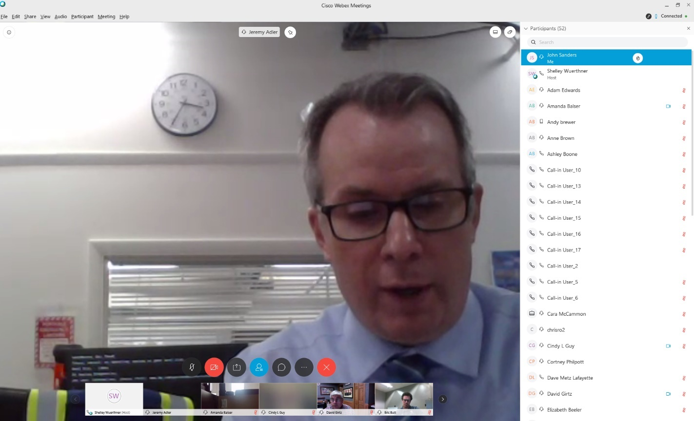

Jeff Houston- TCHD
